**CHINOOK MUSIC STORE SQL PROJECT**

**Objective Questions: -**

1. **Does any table have missing values or duplicates? If yes, how would you handle it?**

* To ensure data integrity and completeness, it is very crucial to identify and handle any missing values (NULLs) in the database tables. The approach I used to detect and handle these null values across different tables.

**Step 1 : Checking for Null Values**I started checking with the customer table for any null values across all the columns. The following SQL query is used to identify rows where any of the columns might contain a null value:

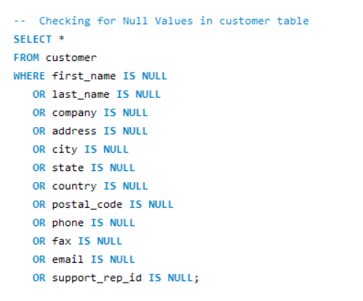

**Step 2: Handling Null Values**

I observed that some columns contained NULL values. To manage this, I replaced NULL values with meaningful defaults based on their data type. Text fields like company, state, and fax were updated with placeholder values like 'UNKNOWN', 'NONE', and 'N/A' by using COALESCE function. Similarly, for numerical fields, appropriate default values were assigned. This ensures better data consistency and improves query results readability.

For handling the null values in customer table, the following SQL query was executed:-

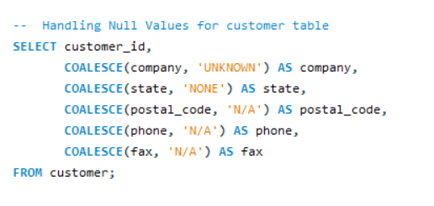

**OUTPUT TABLE:-**

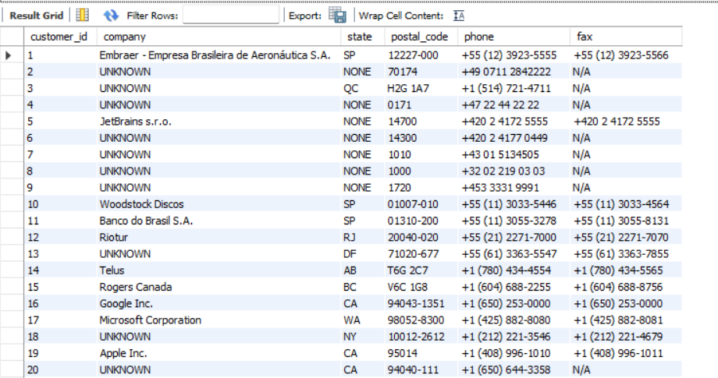

**Applying the Same Approach to Other Tables**

I applied a similar strategy to other tables in the database. To check for null values in the "employee" and "track" table and replace them, the following SQL queries were used:

**Checking null values: -**

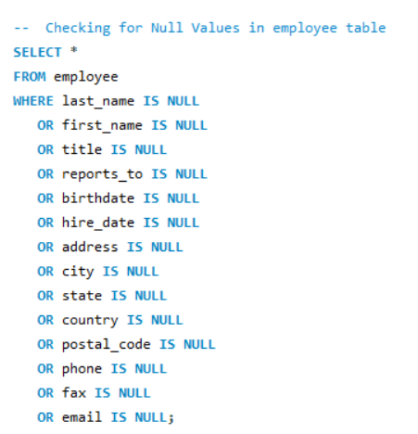 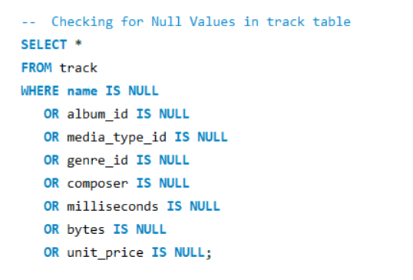

**Handling null values: -**

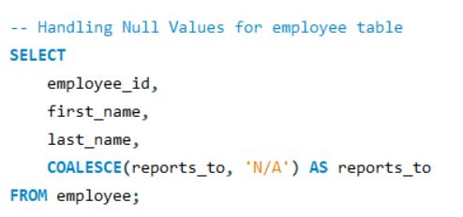 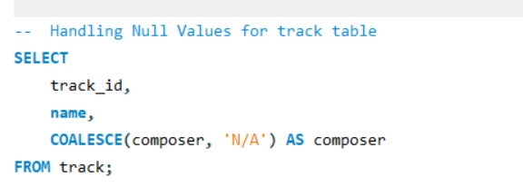

**Table Output:-**

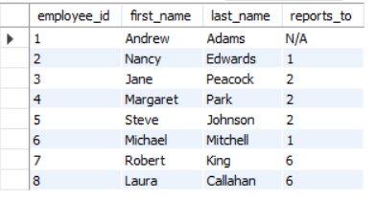 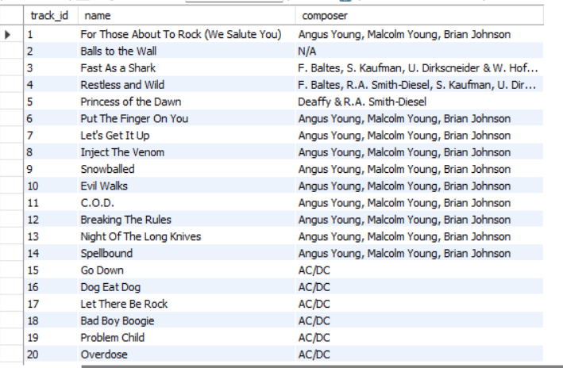

1. **Find the top-selling tracks and top artist in the USA and identify their most famous genres.**

**-> Top Selling Tracks in USA –**

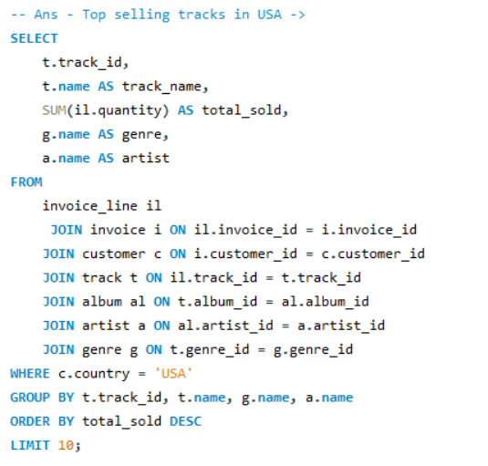

**Table Output –**

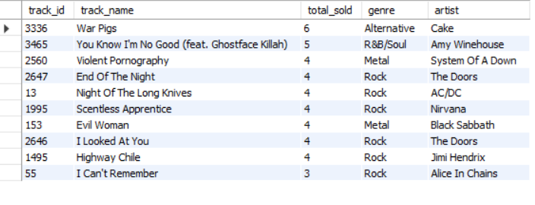

**Approach -**

* **Joined multiple related tables to brings together all necessary info to link sales data with specific music tracks.**
* **Applied a filter to include only U.S. sales using WHERE country = 'USA'. This ensures the data reflects only purchases made by customers in the United States.**
* **Grouped the data by track, artist, and genre, then sums up total sales per track. Sorted the data based on total sales in descending order & finally fetched top 10 tracks from the table, ordered by total sales. This gives a clear list of the most popular tracks in the USA by revenue.**

**Insights –**

‘**War Pigs by Cake**’ & **‘You Know I'm No Good** (feat. Ghostface Killah)’ by Amy Winehouse are the top selling tracks, each selling **6 and 5 units** respectively.

**Top Artist in USA and Most Famous Genres of the Top Artist –**

**Approach -**

* **Joined multiple related tables to brings together all necessary info to link sales data with specific artists.**
* **Applied a filter to include only U.S. sales using WHERE country = 'USA'. This ensures the data reflects only purchases made by customers in the United States.**
* **Grouped the data by artist and genre, then sums up total sales per track. Sorted the data based on total sales in descending order & finally fetched top artist from the table, ordered by total sales. This gives a clear list of the most popular artist in the USA by sales.**

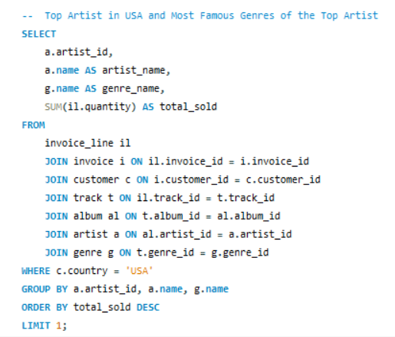

**Table Output –**

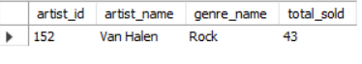

**Insights -** The data reveals that **Van Halen** is a top artist in the USA, with widespread popularity and strong sales performance. The total sales of 43 units indicate a well-established fan base and the enduring appeal of their music. Additionally, the most famous genre of this top artist is **Rock**, signifies the genre's strong presence and influence in the music industry. This suggests that Rock continues to attract a dedicated audience, contributing to Van Halen's success.

1. **What is the customer demographic breakdown (age, gender, location) of Chinook's customer base?**

**->**

**Approach: Customer Demographic Breakdown by Country, State & City**

**The query selects country, state (with NULL replaced by 'NONE'), and city from the customer table. It counts the number of unique customer_id values in each combination of country, state, and city. The results are grouped by country, state, and city, and ordered by country.**

**Query -**

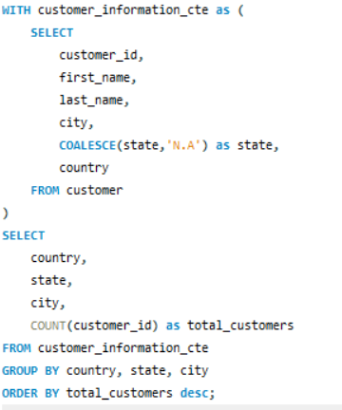

**Table Output –**

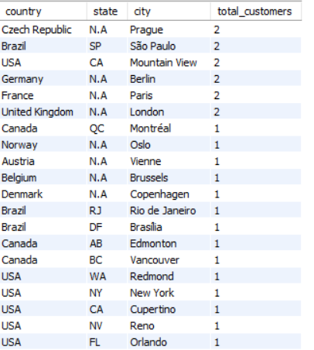

**Insights –**

* The data shows that **São Paulo in Brazil, Paris in France, London in the UK, etc.** are the cities with the highest number of customers, each having **2 customers**.
* Many countries have only one city listed, suggesting a more **limited customer base** in those locations compared to cities with higher counts.

1. **Calculate the total revenue and number of invoices for each country, state, and city:**

**->**

**Approach:**

* **The query retrieves billing country, state, and city to analyze revenue sources. It also calculates total_revenue and counts the number of invoices per location. The total sales revenue for each city-level billing location helps to identify high-revenue geographic areas, the number of transactions in each location it shows both high-frequency and high-value billing locations. Data is grouped by country, state, and city to aggregate at a local level. Results are sorted by total_revenue and then by num_of_invoices in descending order.**

**Query-**

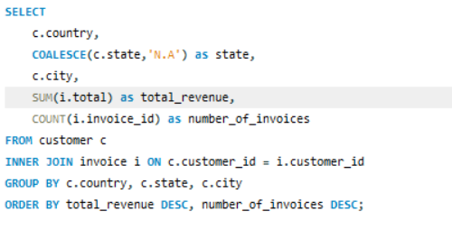

**Table Output –**

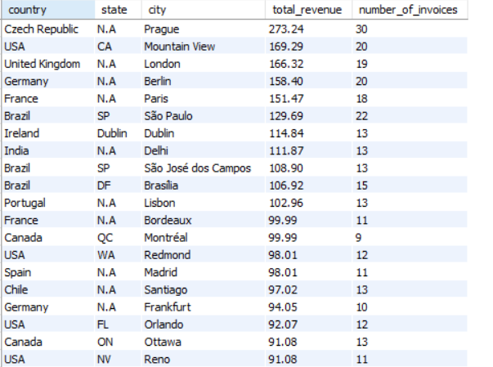

**Insights –**

* **Prague in Czech Republic** has the highest total revenue at **$273.24 with 30 invoices**, highlighting its significant market potential.
* **Mountain View (USA)** and **London (United Kingdom)** show strong performance with high total revenues of **$169.29 and $166.32** respectively, reflecting their high volume of transactions and possibly higher pricing.
* USA shows a **diverse revenue distribution** with cities like Mountain View and New York achieving notable revenues, **$169.29 and $79.20** respectively, showcasing the strength of various US cities.
* Several countries like **Canada and Australia** have **lower revenue** figures despite a decent number of invoices, suggesting that while there is consistent business, the average revenue per invoice might be lower.

1. **Find the top 5 customers by total revenue in each country**

**Approach:**

* **The query joins customer and invoice tables using customer_id it enables aggregation of total revenue for each customer & assigned a rank to each customer within their country based on revenue. The query selects only the top 5 ranked customers per country for clear comparison.**
* **Query -**

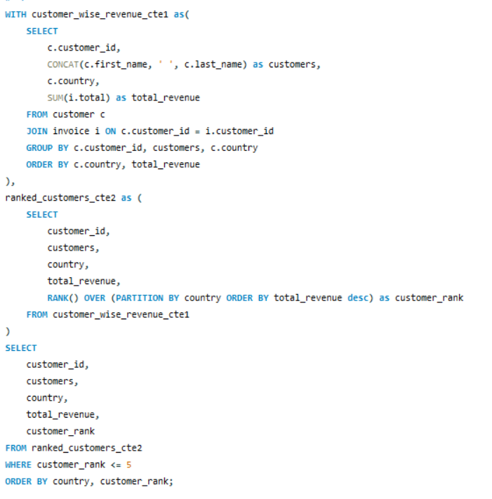

**Table Output -**

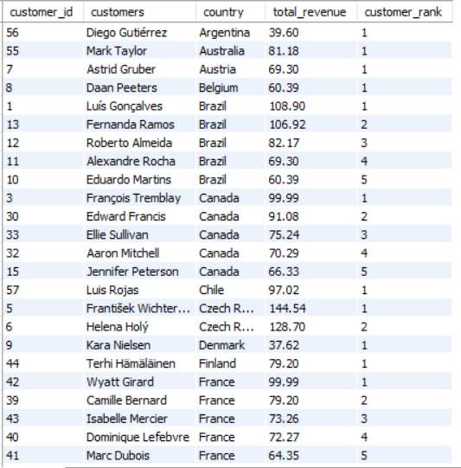

**Insights –**

* Top Customers by Revenue: **František Wichterlová from the Czech Republic** is the **highest** revenue-generating customer with a total of **$144.54**. This suggests strong individual customer value in this region.
* Diverse High Revenue Contributions: Several countries, including **Brazil, India, Ireland, and Portugal**, have customers with revenues **exceeding $100**, indicating strong sales from diverse regions.
* Notable Repeat Customers: In countries like Brazil, Canada, and Germany, there are multiple customers listed with varying revenues, showing a broad customer base contributing to total sales.
* Consistent Revenue Across Regions: There is a notable consistency in customer revenues across different countries, with many customers contributing **between $60 and $100**, indicating steady performance across global markets.
* Unique High Performers: Certain countries have standout high-revenue customers like **Manoj Pareek in India ($111.87)** and **Hugh O'Reilly in Ireland ($114.84)**, indicating exceptional individual performances in these regions.

1. **Identify the top-selling track for each customer**

**Approach :-**

* It calculates total quantity and sales per track for each customer. It also ranks tracks by total sales per customer using ROW_NUMBER(). The query joins customer, invoice, invoice_line, and track tables this links each customer to the tracks they purchased and their corresponding sales. The query retrieves the top track (by revenue) per customer along with total quantity and sales. Results are sorted in descending order of total sales to highlight top-performing purchases.

**Query –**

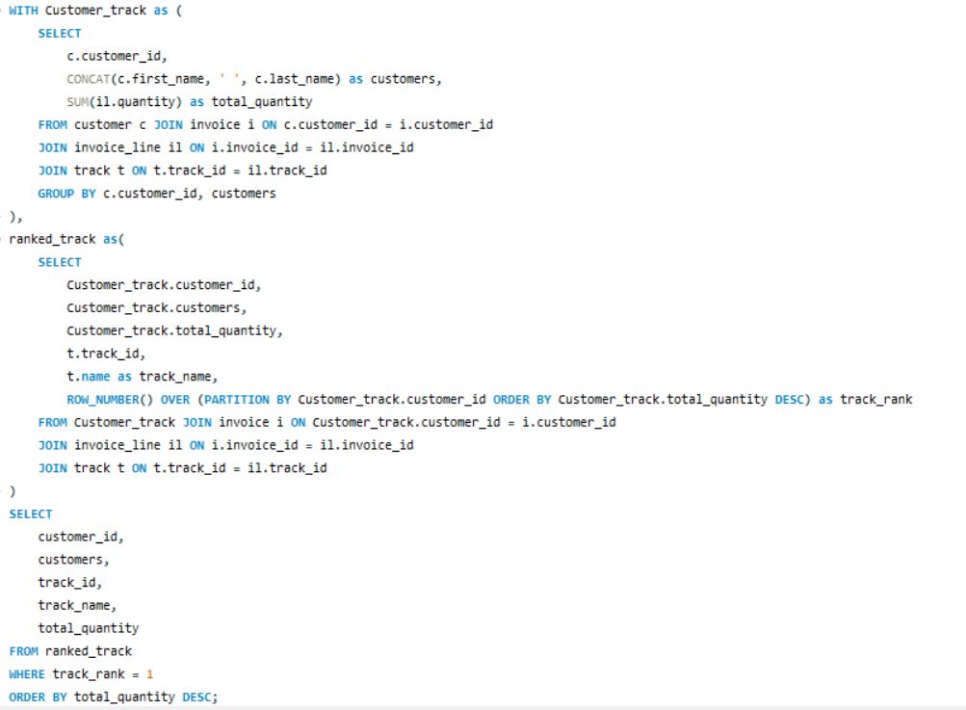

**Table Output –**

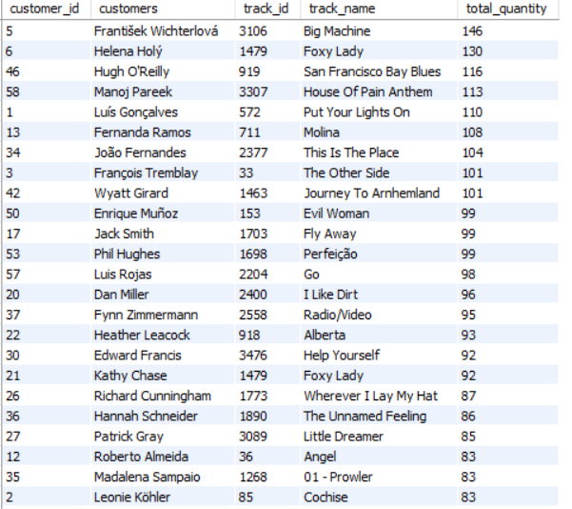

**Insights –**

* **"Big Machine", "Foxy Lady", and "House Of Pain Anthem"** are the most popular tracks, with **over 100 units** sold each.
* Several customers show high engagement, purchasing large quantities of their preferred tracks.
* There's a wide variety of tracks purchased, indicating diverse musical tastes among customers.
* Some tracks, like "**Foxy Lady**" are popular with multiple customers, showing broad appeal.
* High purchase quantities are seen across different countries, reflecting strong global demand.

1. **Are there any patterns or trends in customer purchasing behaviour (e.g., frequency of purchases, preferred payment methods, average order value)?**

* **Ans –**

**Approach -**

* We are calculating total purchases, first and latest purchase dates, and average days between purchases for each customer by joining the customer and invoice tables on customer_id. Results are ordered by average days between purchases (ascending) and total purchases (descending).

**Query -**

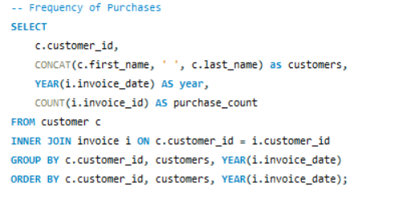

**Table Output -**

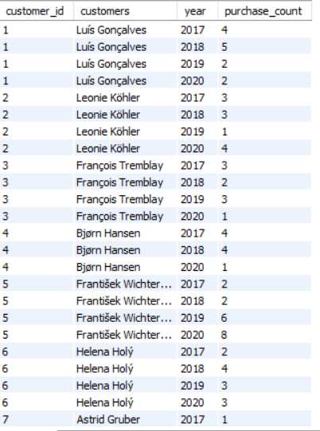

**Insights -**

* **František Wichterlová** had a significant increase in purchases, **from 2 in 2017 to 8 in 2020**, showing growing engagement.
* Many customers, like LuÃs GonÃ§alves and Fernanda Ramos, showed **varied purchase behaviour** across years, indicating inconsistent buying patterns.
* Some customers, such as Hugh O'Reilly and Edward Francis, had more stable or slightly fluctuating purchase counts over the years.
* **2020 saw a mix of increased and decreased purchases** among different customers, reflecting diverse trends possibly influenced by external factors.
* Several customers had notable **high purchase years**, such as **Martha Silk in 2017 with 6 purchases** and **Edward Francis in 2020 with 6 purchases.**

**Calculate the average order value for each customer -**

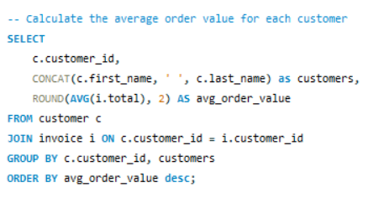

**Table Output –**

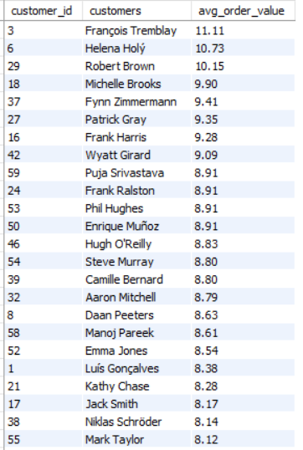

**Insights –**

* **François Tremblay** has the highest average order value at **$11.11**, followed closely by Helena Holý and Robert Brown.
* Most customers have an average order value **between $7 and $9**, indicating a moderate spending range.
* Kara Nielsen and Mark Philips have the lowest average order values, suggesting they make smaller or less frequent purchases.
* A few customers, like Michelle Brooks and Fynn Zimmermann, have relatively high **average order values** **around $9**, highlighting their higher spending per transaction.

**Calculate the total revenue generated by each customer -**

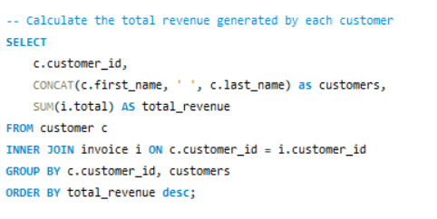

**Table Output –**

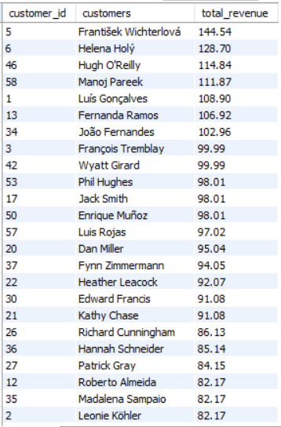

**Insights –**

* **František Wichterlová** leads with the highest total revenue of **$144.54**, followed by Helena Holý and Hugh O'Reilly.
* The **top 10 customers** all have total revenues **above $98**, indicating strong purchasing behaviour.
* Most customers have total revenues **between $60 and $100**, showing consistent spending across the customer base.
* **Lower revenue customers**, such as Diego Gutiérrez and Kara Nielsen, have total revenues **below $40**, suggesting lower engagement or fewer purchases.

**Identify the preferred purchase periods -**

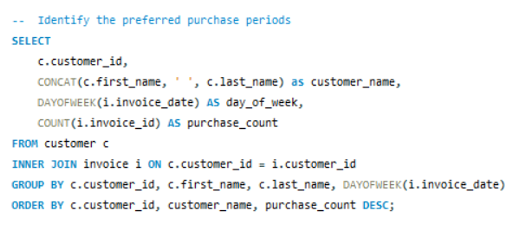

**Table Output –**

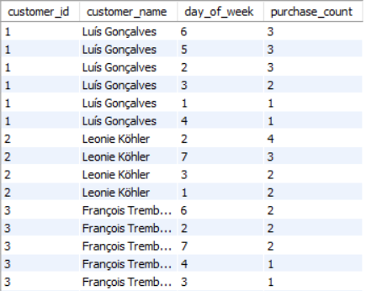

**Insights –**

* Most customers have their **highest purchase counts** spread across multiple days of the week, indicating **varied shopping habits**.
* **František Wichterlová** is among the top with significant purchases on specific days, showing concentrated buying behaviour.
* Several customers, like **Luís Gonçalves** and **Hugh O'Reilly**, make purchases consistently across different days, indicating steady engagement.
* **Weekends (day 7)** show notable purchases for many customers, suggesting increased activity during weekends.

1. **What is the customer churn rate?**

Ans –

Churn Rate = (Number of customers lost during a period / Number of customers at the start of the period) × 100

For this calculation, a customer is considered churned if they have not made any purchase for more than 6 month (Assuming to 180 days) between their last and second-last purchase dates.

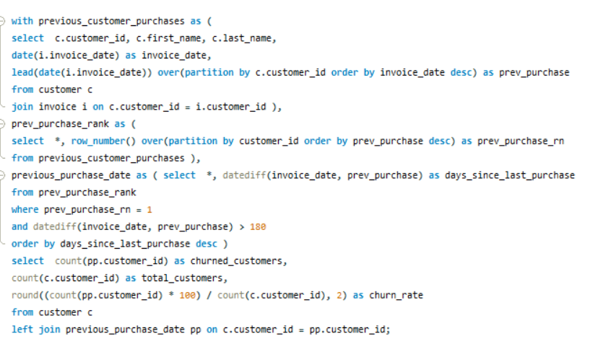

**Table Output –**

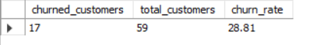

**Insights –**

* The customer churn rate is **28.81**, indicating that approximately **29%** of customers are leaving over a specific period.
* About **71%** of your customers are still active, the retention is relatively good, but there's room for improvement.
* Maintaining a **low churn rate** is crucial for long-term business growth and customer loyalty, so here we need to reduce that.
* Strategies to further reduce churn could involve improving **customer engagement**, **enhancing service quality**, and addressing customer feedback.

1. **Calculate the percentage of total sales contributed by each genre in the USA and identify the best-selling genres and artists.**

**Approach –**

* The query shows each genre, artist, their total sales, their rank within the genre, and the percentage of total USA sales that each artist’s sales represent. Results are sorted by sales and genre. The query calculates the total sales for each artist within their genre in the USA, using data from multiple tables related to genres, tracks, invoices, and artists. It calculates the overall total sales in the USA, considering all genres and artists.

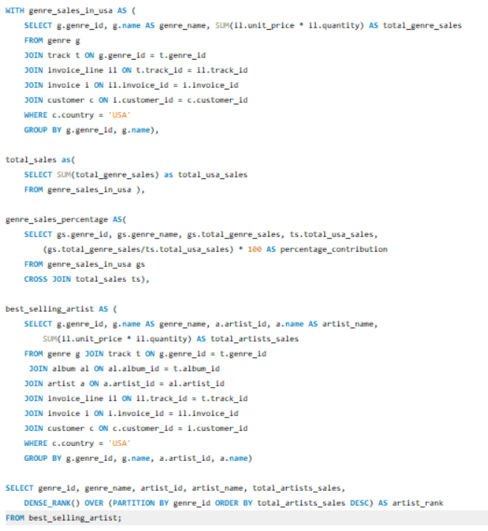

**Table Output –**

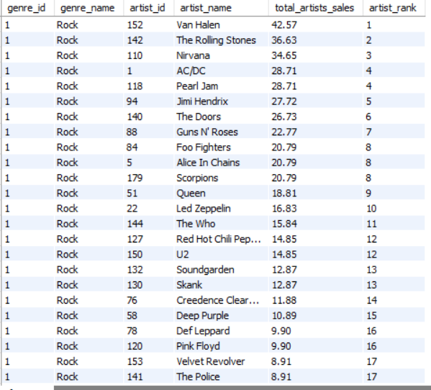

**Insights –**

* **Van Halen** leads Rock genre sales with **42.57**, followed by The Rolling Stones and Nirvana, showing their popularity.
* **Black Sabbath and System of a Down** top **Metal** sales, highlighting their dominance in the genre.
* **Eric Clapton** is the **highest-selling Blues artist** with significant sales compared to other Blues artists.
* **Amy Winehouse** is the **top-selling** artist in the **Pop and R&B/Soul genres**, indicating broad appeal across genres.
* The **Jazz** and **Classical** genres have relatively low sales compared to other genres, suggesting niche markets.

1. **Find customers who have purchased tracks from at least 3 different genres**

Ans-

Approach –

* It combines customer information with their invoice, tracks they bought, and the genres of those tracks. For each customer, it counts how many different genres they have purchased music from. It only shows customers who have bought music from **3 or more different genres**.

**Query –**

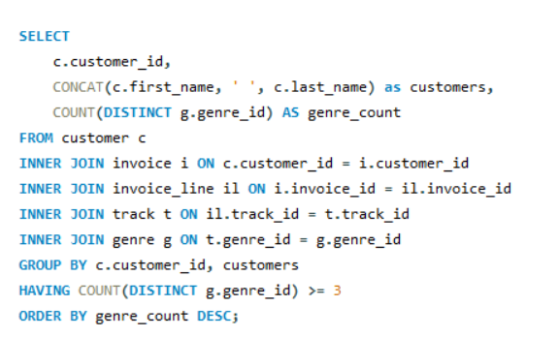

**Table Output –**

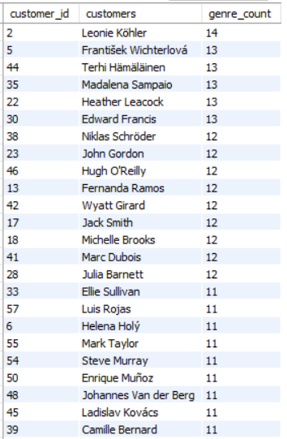

**Insights -**

* **Leonie Köhler** explores the most diverse range of genres, engaging with **14** different types.
* Several customers, including **František Wichterlová** and **Terhi Hämäläinen**, engage with **13 genres**, indicating a broad musical taste.
* A significant number of customers interact with **10 to 12 genres**, showing a preference for **diverse music**.
* Fewer customers, like Robert Brown, engage with only a handful of genres, suggesting more specialized tastes.

1. **Rank genres based on their sales performance in the USA**

**Ans –**

* It looks at total music sales in the USA, grouped by each music genre. Genres are ranked using dense_rank(), so genres with the highest sales get the top rank (1st, 2nd, etc.). The final output lists genres with their total USA sales and sales rank, ordered by rank from highest to lowest.

**Query –**

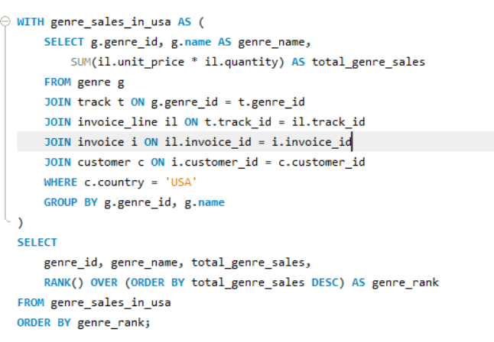

**Table Output –**

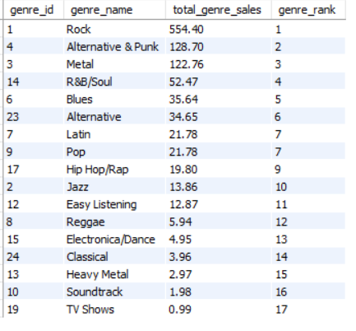

**Insights –**

* **Rock** is the top genre by a significant margin, with total sales of **555.39**, indicating its widespread popularity.
* Alternative & Punk and Metal follow as the second and third most popular genres, with sales of **128.7** and **122.76**, respectively.
* **R&B/Soul** and **Blues** are **mid-ranked genres**, showing moderate popularity with total sales of **52.47** and **35.64.**
* Genres like **Classical, Heavy Metal, Soundtrack**, and **TV Shows** have the **lowest sales**, reflecting niche or limited audience appeal.

1. **Identify customers who have not made a purchase in the last 3 months.**

Ans –

To identify customers who have not made a purchase in the last 3 months, we need data on their recent purchase dates.

Approach –

* It first creates a list of customers with their last purchase date by finding the most recent invoice for each customer. Then creates another list showing each customer’s individual purchases along with the invoice date for each. The query identifies customers who haven’t made a purchase in the last 3 months (from their last purchase date).

**Query -**

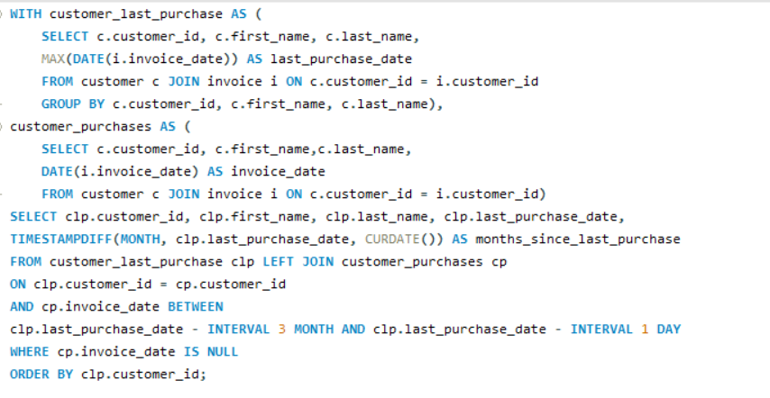

**Table Output –**

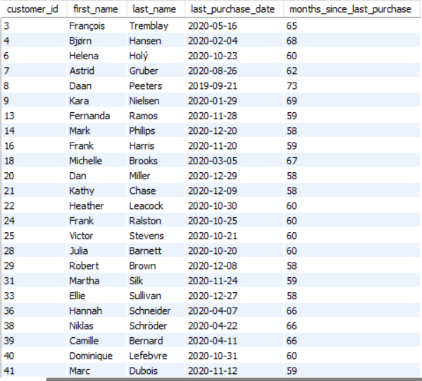

**Insights –**

* The list provides 59 customer names who did not made a purchase in the last 3 months.

****************** END OF OBJECTIVE QUESTIONS ******************

**SUBJECTIVE QUESTIONS**

1. **Recommend the three albums from the new record label that should be prioritized for advertising and promotion in the USA based on genre sales analysis.**

**Ans –**

**Query –**

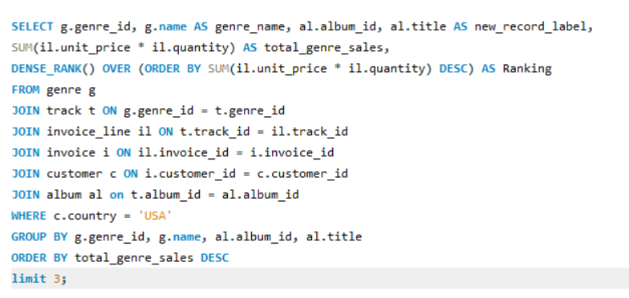

**Based on my analysis following 3 albums should be prioritized for advertising and promotion in USA:**

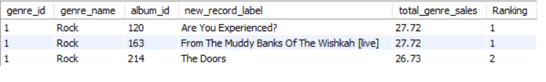

**1. "Are You Experienced?" (Rock)**

* **Album ID: 120**
* **Total Genre Sales: 27.72**
* **Ranking: 1**

**2. "From The Muddy Banks Of The Wishkah [live]" (Rock)**

* **Album ID: 163**
* **Total Genre Sales: 27.72**
* **Ranking: 1**

**3. "The Doors" (Rock)**

* **Album ID: 214**
* **Total Genre Sales: 26.73**
* **Ranking: 2**

**INSIGHTS:**

* **Genre Popularity:** Rock is the dominant genre with the highest total sales figures. The top three albums all belong to this genre, indicating a strong market preference for Rock music in the USA.
* **Sales Figures:** The selected albums have the highest total genre sales, making them strong candidates for promotion.

**The strong sales performance of these albums in the Rock genre, they should be prioritized for advertising and promotion in the USA to capitalize on their popularity. The below mentioned chart “Top 3 albums” compares three music albums based on their total genre sales and ranking. Blue bars represent sales, while orange bars show rankings, making it easy to visually compare their performance.**

1. **Determine the top-selling genres in countries other than the USA and identify any commonalities or differences.**

**Ans -**

**Query –**

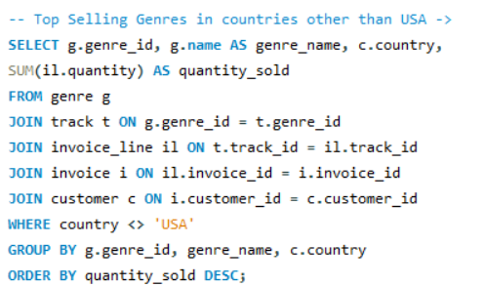 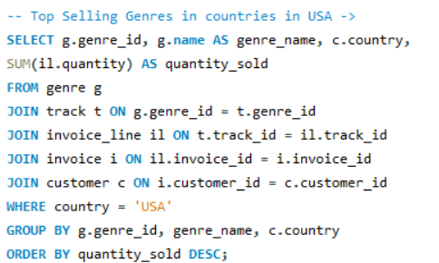

**Output –**

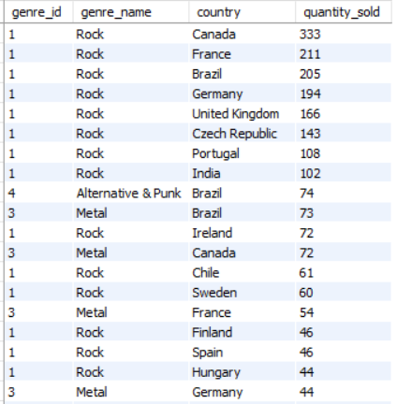 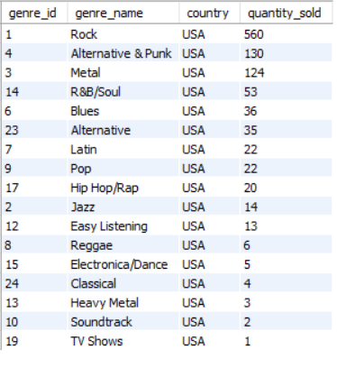

**Top-Selling Genres in Countries Other Than the USA:**

**Rock:**

Canada: 333 units sold

France: 211 units sold

Brazil: 205 units sold

Germany: 194 units sold

United Kingdom: 166 units sold

Czech Republic: 143 units sold

Portugal: 108 units sold

India: 102 units sold

Ireland: 72 units sold

Chile: 61 units sold

Sweden: 60 units sold

**Alternative & Punk:**

Brazil: 74 units sold

**Metal:**

Brazil: 73 units sold

Canada: 72 units sold

**COMMONALITIES:**

* **Rock dominates** in almost all the countries listed, indicating a strong global preference for Rock music outside the USA.
* **Metal and Alternative & Punk are also popular in Brazil**, showing a more diverse taste in music genres in that country.
* **Rock is the top genre** in every country mentioned except for the specific instances where Metal or Alternative & Punk are highlighted.

**DIFFERENCES:**

* **Brazil** stands out with **significant sales in both Alternative & Punk and Metal genres**, in addition to Rock, showing a more varied musical taste compared to other countries.
* **Metal** has a notable presence in **Canada and Brazil** but does **not appear as a top genre** in other countries listed.
* The sales volume for genres other than Rock is generally lower in all non-USA countries, indicating **Rock’s dominance**.

**INSIGHTS:**

* **Rock** is the overwhelmingly **dominant genre** across most countries, indicating a universal appeal.
* **Brazil** has a **more diverse taste**, with strong sales in Alternative & Punk and Metal alongside Rock.
* The preference for **Metal** is notably **strong in Canada and Brazil**, which differs from other countries where Rock dominates.
* This analysis shows that while **Rock is a global favourite**, countries like **Brazil exhibit broader genre preferences**, which could be important for tailored marketing and promotion strategies.

|  |  |  |  |  |
| --- | --- | --- | --- | --- |
| **Country other than USA's genre wise quantity sold** | |  | **USA's genre wise quantity sold** | |
| **Genre Name** | **Total Quantity sold** |  | **Genre Name** | **Total Quantity sold** |
| Rock | 2074 |  | Rock | 560 |
| Metal | 495 |  | Alternative & Punk | 130 |
| Alternative & Punk | 362 |  | Metal | 124 |
| Latin | 145 |  | R&B/Soul | 53 |
| Jazz | 107 |  | Blues | 36 |
| R&B/Soul | 106 |  | Alternative | 35 |
| Blues | 88 |  | Latin | 22 |
| Alternative | 82 |  | Pop | 22 |
| Easy Listening | 61 |  | Hip Hop/Rap | 20 |
| Electronica/Dance | 50 |  | Jazz | 14 |
| Classical | 43 |  | Easy Listening | 13 |
| Pop | 41 |  | Reggae | 6 |
| Reggae | 29 |  | Electronica/Dance | 5 |
| Hip Hop/Rap | 13 |  | Classical | 4 |
| Heavy Metal | 5 |  | Heavy Metal | 3 |
| Soundtrack | 3 |  | Soundtrack | 2 |
| TV Shows | 1 |  | TV Shows | 1 |
| Drama | 1 |  | **Grand Total** | **1050** |
| **Grand Total** | **3706** |  |  |  |

Tools used - MS-EXCEL ---> Pivot Table

1. **Customer Purchasing Behaviour Analysis: How do the purchasing habits (frequency, basket size, spending amount) of long-term customers differ from those of new customers? What insights can these patterns provide about customer loyalty and retention strategies?**

**Ans –**

To analyse customer purchasing behaviour and compare the habits of long-term customers with those of new customers, we can use the following SQL query. This query will compute the purchase frequency, average basket size, and average spending amount for both customer groups.

**Query -**

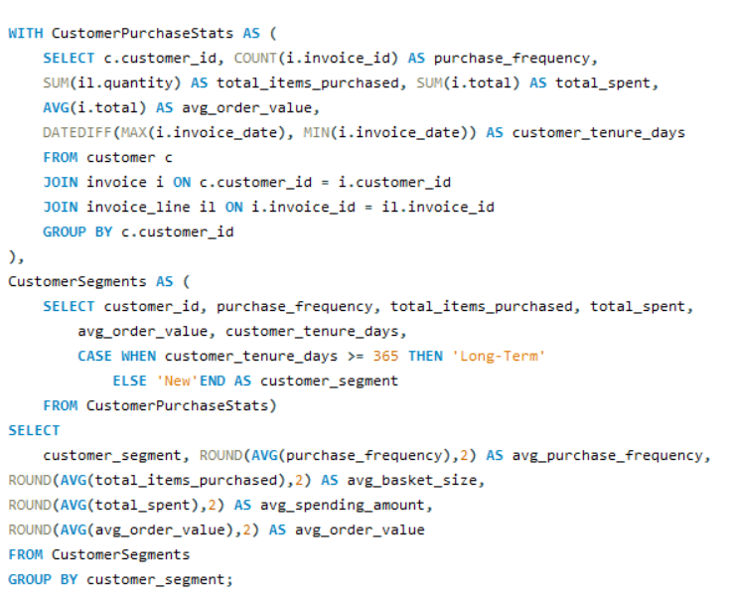

**Table Output –**

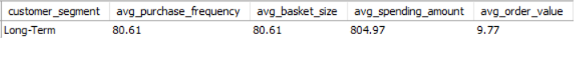

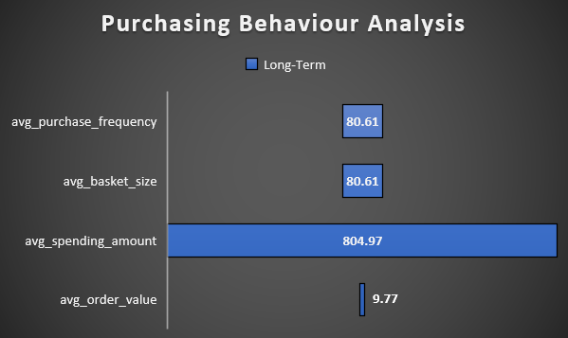

**INSIGHTS:**

* **Purchase Frequency**: By comparing avg_purchase_frequency, we can determine whether long-term customers make purchases more frequently than new customers.
* **Basket Size**: The avg_basket_size indicates whether long-term customers tend to buy more items per order compared to new customers.
* **Spending Amount**: The avg_spending_amount helps in understanding whether long-term customers spend more money overall, which could be a sign of loyalty and satisfaction.
* **Order Value**: The avg_order_value reveals whether long-term customers place higher-value orders, which could indicate trust and a preference for the product offerings.

**RECOMMENDATION:**

These insights can inform customer loyalty and retention strategies, such as offering personalized promotions to long-term customers or targeted marketing campaigns to encourage repeat purchases from new customers.

1. **Product Affinity Analysis: Which music genres, artists, or albums are frequently purchased together by customers? How can this information guide product recommendations and cross-selling initiatives?**

Ans –

1. **Frequently Purchased Genres Together:**

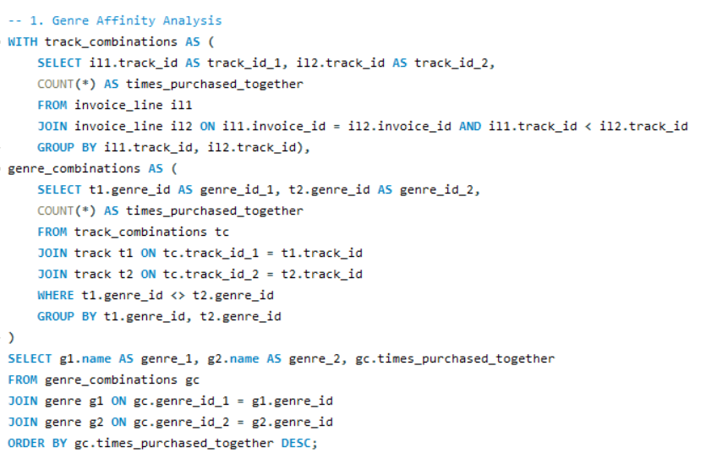

**Table Output -**

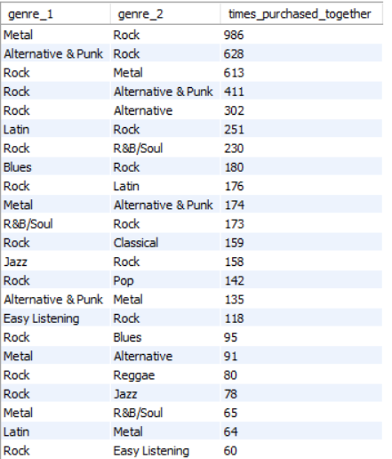

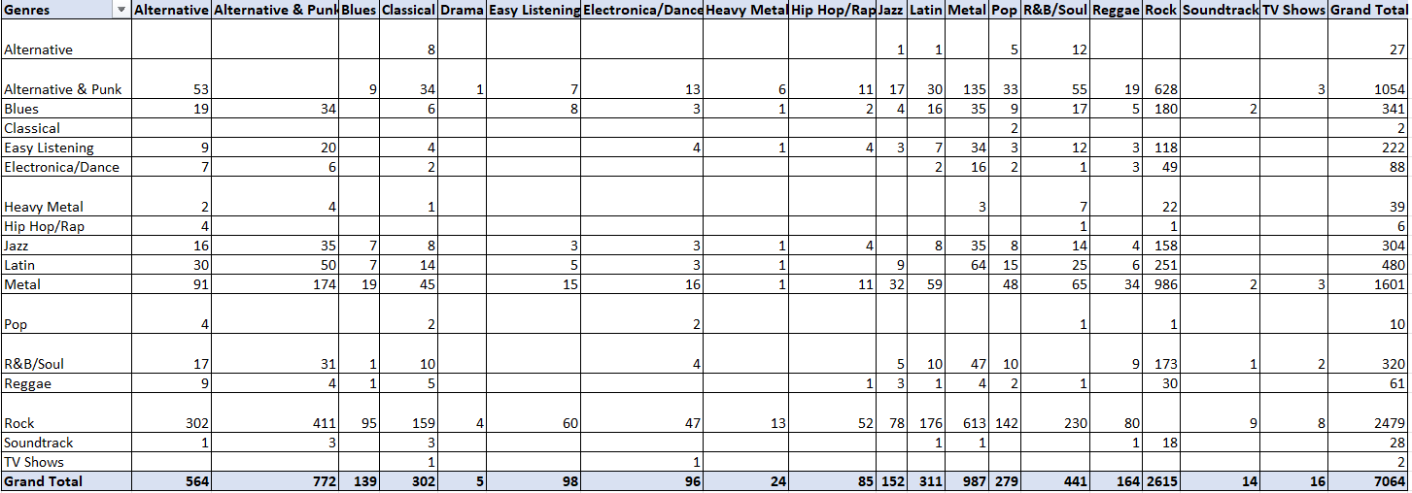

**INSIGHTS:**

* **Metal** and **Rock** are the most frequently purchased together, indicating a strong overlap in fan base.
* **Alternative & Punk and Rock** also show significant co-purchase rates, suggesting shared listener preferences.
* **Latin and R&B/Soul** genres have notable pairings with Rock, pointing to potential opportunities for cross-genre promotions.

**RECOMMENDATIONS:**

* **Bundle Offers:** Combine Metal and Rock albums, along with Alternative & Punk with Rock for popular bundles.
* **Cross-Promotions:** Promote Metal albums to Rock fans and vice versa, leveraging their shared appeal.

In this way I hope the cross-selling initiative can be performed so that all the possible genres would get good amount of sales.

1. **Frequently Purchased Artists Together ->**

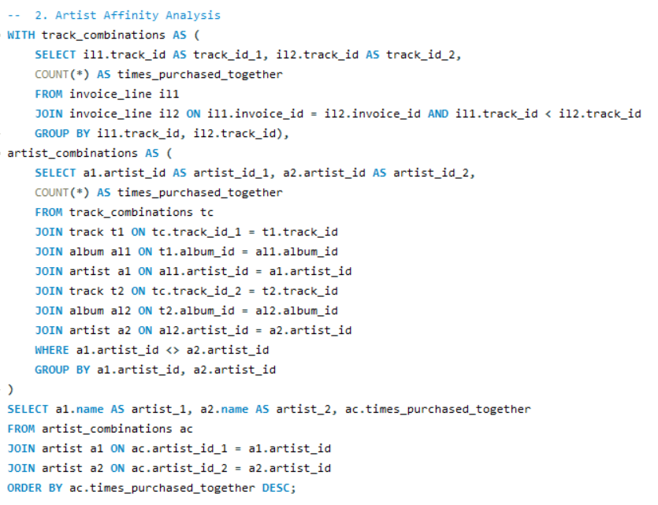

**Table Output –**

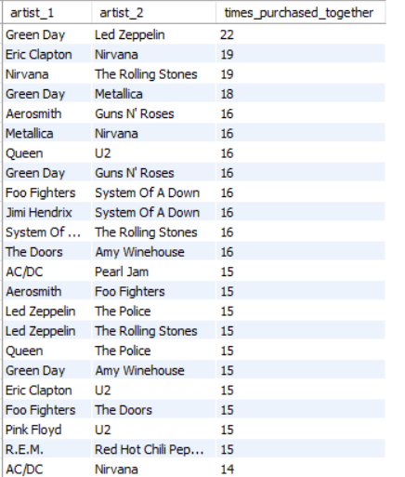

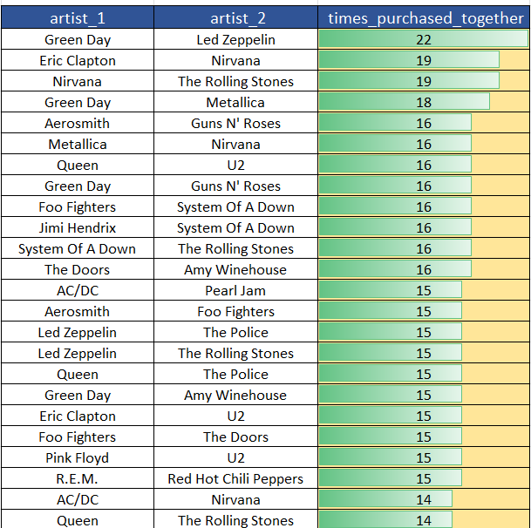

**INSIGHTS:**

* **Green Day and Led Zeppelin** are frequently purchased together, indicating strong cross-genre appeal.
* **Nirvana and The Rolling Stones**, as well as Eric Clapton and Nirvana, show notable co-purchase patterns, suggesting these artist pairings resonate with similar audiences.
* Artists like System Of A Down and Foo Fighters, and Queen and The Police, also have significant co-purchases, highlighting popular combinations among listeners.

**RECOMMENDATIONS:**

* **Artist Pairing Promotions:** Offer discounts on Green Day and Led Zeppelin albums purchased together and apply similar deals to pairings like Eric Clapton and Nirvana.
* **Playlist Curation:** Create playlists featuring frequently paired artists to appeal to similar tastes.

1. **Frequently Purchased Albums Together ->**

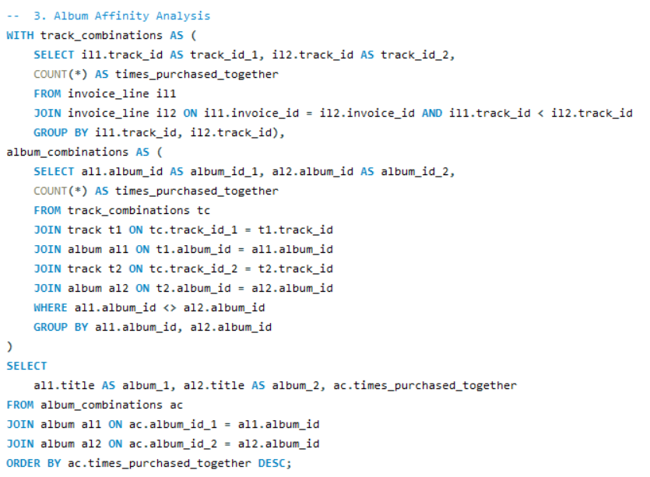

**Table Output –**

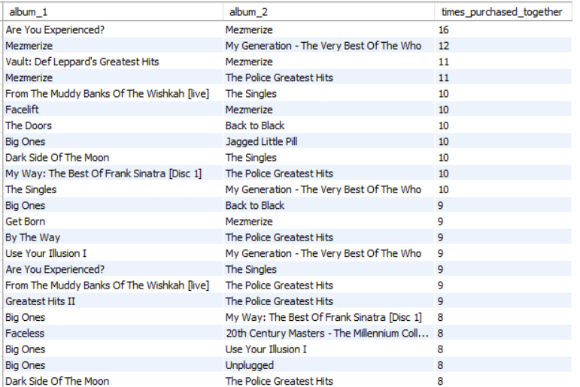

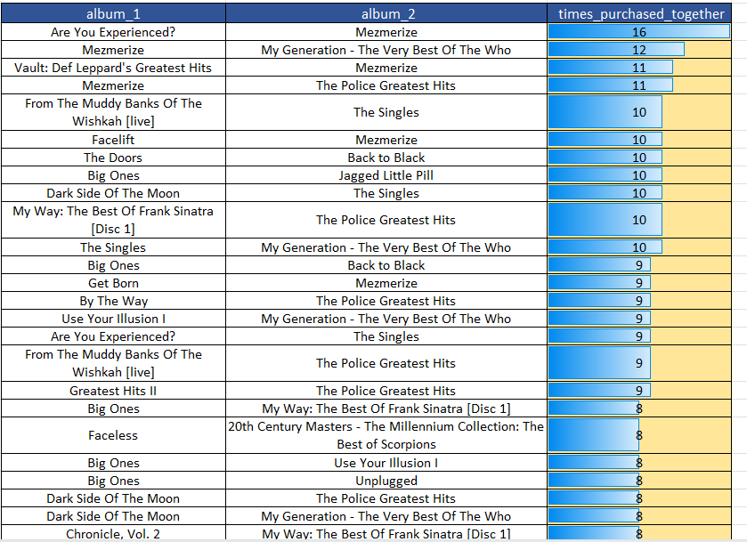

**INSIGHTS:**

* **"Mesmerize" is a popular album paired with several others, including "Are You Experienced?" and "The Police Greatest Hits," indicating it resonates well with fans of diverse classic rock albums.**
* **Albums like "The Police Greatest Hits" and "My Generation - The Very Best Of The Who" frequently appear together, suggesting a strong preference for classic rock compilations.**
* **"Big Ones" and "Back to Black" also show notable co-purchase rates, highlighting popular cross-genre interests among listeners.**

**RECOMMENDATIONS:**

* **Album Pair Deals: Offer combined deals on album pairs like "Are You Experienced?" and "Mezmerize."**
* **Special Editions: Create box sets with frequently paired albums to attract collectors.**

**GENERAL CROSS-SELLING INITIATIVES:**

* **Curated Collections: Create and market "Perfect Pairings" or "Ultimate Combo Packs" based on genre and artist affinities.**
* **Personalized Recommendations: Suggest related albums (e.g., Metal or Alternative & Punk) when a customer buys a Rock album.**
* **Targeted Marketing: Use email, ads, or notifications to promote synergies between popular genres, artists, and albums.**

1. **Regional Market Analysis: Do customer purchasing behaviours and churn rates vary across different geographic regions or store locations? How might these correlate with local demographic or economic factors?**
2. **Customer Purchasing Behaviours:**

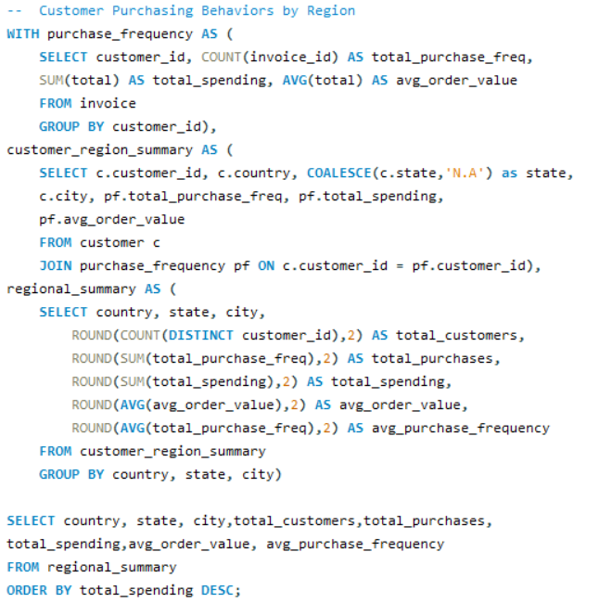

**Table Output –**

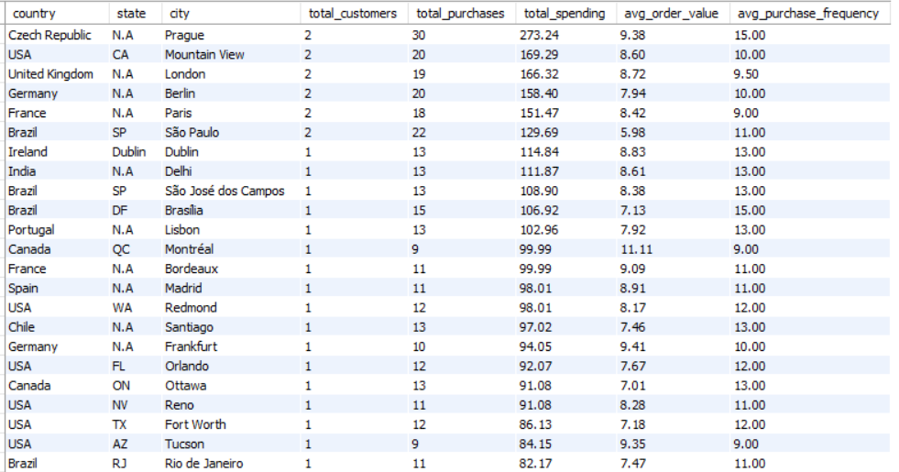

* 1. **High Average Order Value & Purchase Frequency:**
  + Prague, Czech Republic: $9.38 average order value, frequency 15.
  + Mountain View, USA: $8.60 average order value, frequency 10.
  + London, UK: $8.72 average order value, frequency 9.5.

**Insight:** Target affluent regions with premium products and tailored marketing.

* 1. **Moderate Average Order Value & Purchase Frequency:**
  + São Paulo, Brazil: $5.98 average order value, frequency 11.
  + Berlin, Germany: $7.94 average order value, frequency 10.

**Insight:** Focus on customer retention and repeat purchase strategies.

* 1. **Low Average Order Value & Purchase Frequency:**
  + Edmonton, Canada: $2.97 average order value, frequency 10.
  + Copenhagen, Denmark: $3.76 average order value, frequency 10.

**Insight:** Use promotions to boost order values and frequency; consider local economic factors.

1. **Churn rates –**

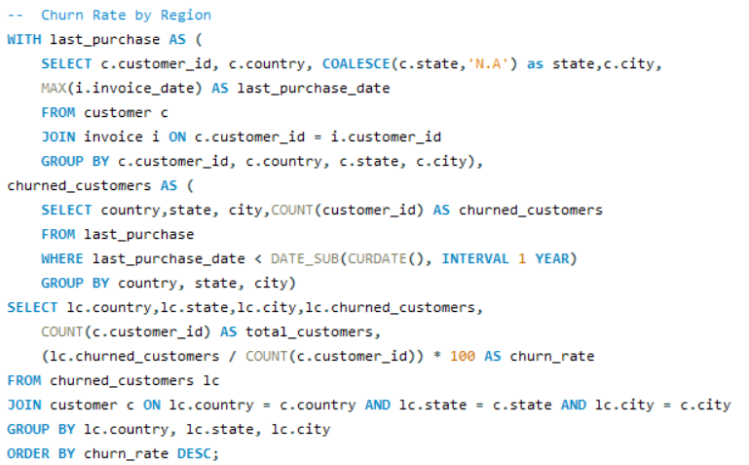

**Table Output –**

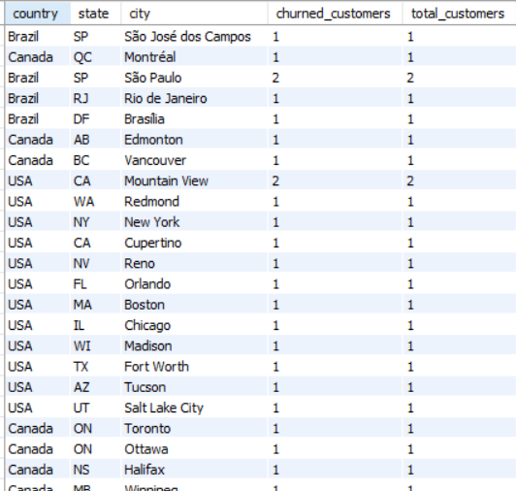

**High Churn Regions:** São José dos Campos, Montréal, São Paulo, Rio de Janeiro, Brasília, Edmonton, Mountain View, and Redmond.

**Insight:** High churn suggests a need for better customer retention strategies, such as loyalty programs and enhanced support.

**CORRELATION WITH LOCAL FACTORS:**

* **Affluent Areas:** High spending and frequency suggest higher income and better economic conditions.
* **Emerging Markets:** Moderate spending with high frequency points to budget-conscious middle-class consumers.
* **High Churn in Competitive Areas:** Competition and high living costs may affect loyalty.

**RECOMMENDATIONS:**

* **High-Value Areas:** Offer exclusive products and premium pricing.
* **Moderate Areas:** Enhance engagement with loyalty programs and value offers.
* **High Churn Areas:** Address churn with discounts, improved service, and feedback collection.

1. **Customer Risk Profiling: Based on customer profiles (age, gender, location, purchase history), which customer segments are more likely to churn or pose a higher risk of reduced spending? What factors contribute to this risk?**

**Ans –**

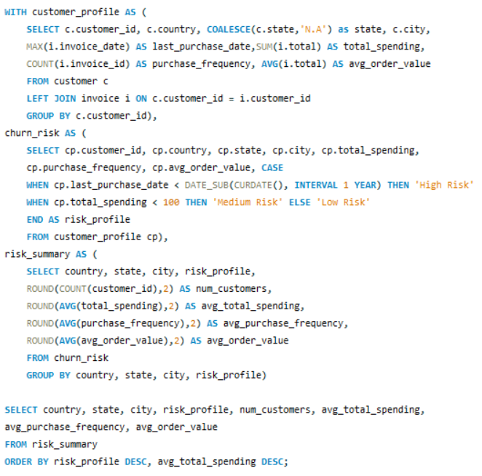

**Table Output –**

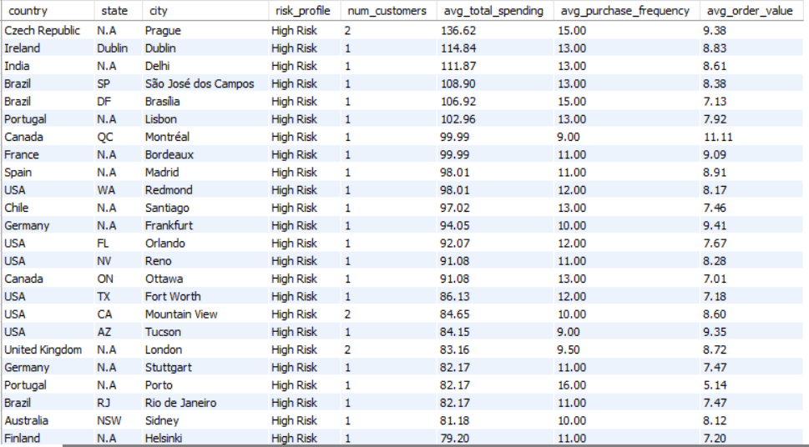

**Below are the key insights and contributing factors to this risk:**

1. **High Spending with High Frequency (Potential Churn Risk):**

* Regions: Prague, Czech Republic; Delhi, India; Brasília, Brazil.
* Risk Factors: High expectations and increased competition may lead to churn if service or deals decline.

1. **Moderate Spending with Moderate Frequency:**

* Regions: Mountain View, USA; Stuttgart, Germany.
* Risk Factors: Dependence on satisfaction and economic sensitivity could lead to reduced spending or churn **if** conditions change.

1. **Low Spending with High Frequency:**

* Regions: Yellowknife, Canada; Stockholm, Sweden.
* Risk Factors: Value-seeking and promotional dependence make these customers sensitive to price increases or reduced deals.

1. **Low Spending with Low Frequency (High Churn Risk):**

* Regions: Edmonton, Canada; Copenhagen, Denmark.
* Risk Factors: Low engagement and price sensitivity increase churn risk if offerings aren't compelling or prices rise.

**FACTORS CONTRIBUTING TO HIGH RISK:**

Economic instability, competitive marketplaces, declining service/product quality, and unmet demographic needs.

**RECOMMENDATIONS:**

* **Enhanced Engagement:** Use loyalty programs and personalized offers for high-spending customers.
* **Value-Based Marketing:** Highlight value for money and maintain promotions for price-sensitive regions.
* **Service Improvement:** Ensure high-quality service to retain frequent buyers.
* **Churn Prediction:** Implement predictive analytics to identify and address at-risk customers early.

These strategies will help reduce churn and maximize customer lifetime value.

1. **Customer Lifetime Value Modelling: How can you leverage customer data (tenure, purchase history, engagement) to predict the lifetime value of different customer segments? This could inform targeted marketing and loyalty program strategies. Can you observe any common characteristics or purchase patterns among customers who have stopped purchasing?**

Ans –

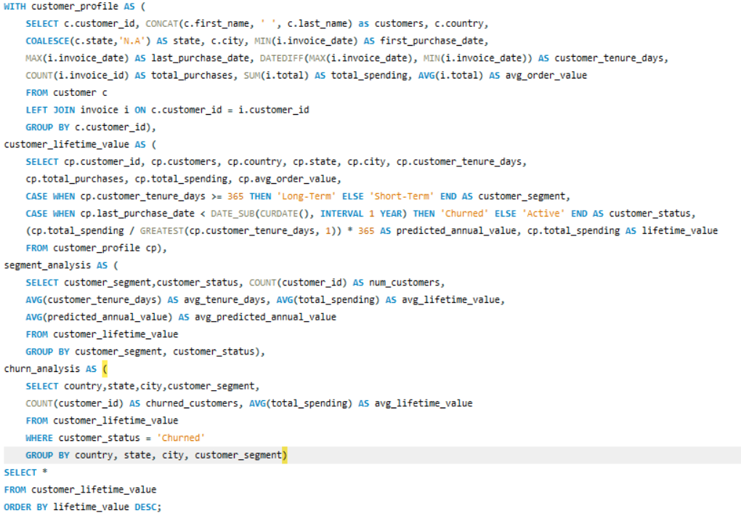

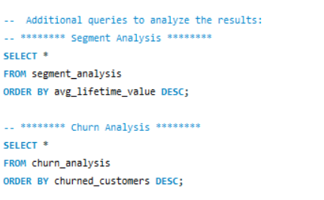

**Table Output -**

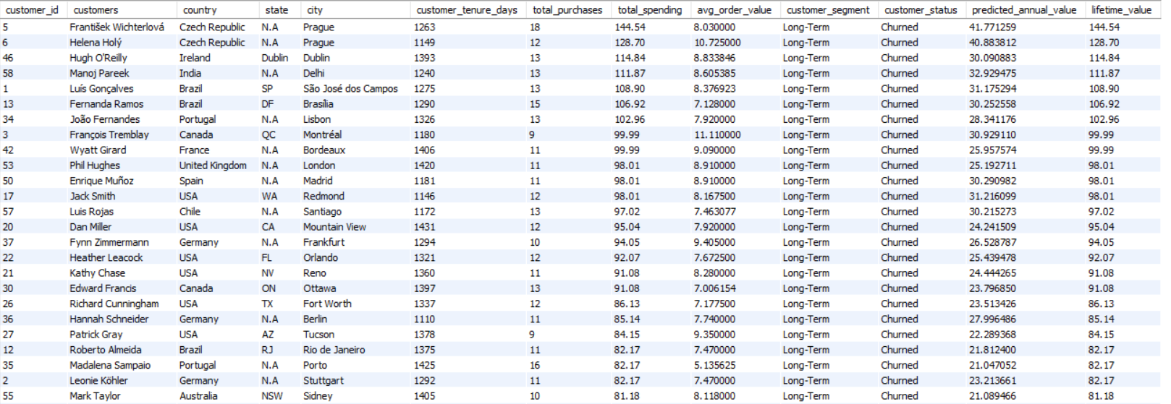

We can analyse the customer lifetime value (CLV) and identify patterns using conditional formatting among customers who have churned.

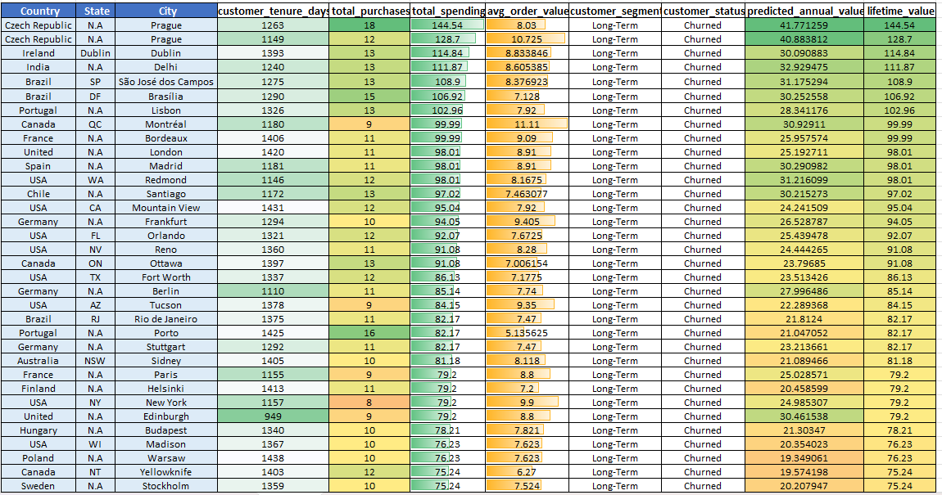

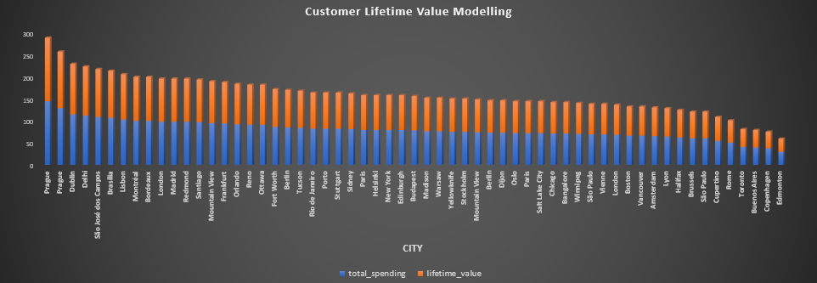

**INSIGHTS:**

1. **Customer Segments and Predicted Lifetime Value:**

* High Lifetime Value Customers: Example: František Wichterlová from Prague. High spending and average order value. Need targeted retention strategies.

1. **Low Lifetime Value Customers**: Example: Mark Philips from Edmonton. Lower spending and order values. More price-sensitive or less engaged.
2. **Common Characteristics of Churned Customers:**

* Long-Term Customers: Churn can occur even with long tenure. Example: Helena Holý from Prague.
* Moderate Spending: Customers with moderate spending may churn due to better alternatives. Example: Camille Bernard from Paris.
* High Risk, Low Engagement: High predicted lifetime value but low engagement. Example: Robert Brown from Toronto.

1. **Observed Purchase Patterns:**

* Higher Engagement: Frequent purchases reduce churn risk.
* Lower Order Value: Customers with low average order values but long tenure may be at risk if they don’t perceive value.

1. **Targeted Marketing and Loyalty Strategies:**

* Personalized Offers: For high CLV customers, use targeted promotions.
* Loyalty Programs: Reward moderate spenders to increase engagement.
* Reactivation Campaigns: For long-term, low-spending customers, offer incentives to boost spending.

**RECOMMENDATIONS:**

Identifying churn patterns and characteristics helps in creating effective retention strategies, enhancing customer loyalty, and reducing churn.

1. **If data on promotional campaigns (discounts, events, email marketing) is available, how could you measure their impact on customer acquisition, retention, and overall sales?**

**Ans –**

We don't have direct access to data related to promotional campaigns such as discounts, events, or email marketing. However, if such data were available, the impact of promotional campaigns on customer acquisition, retention, and overall sales could be measured using the following approach:

**APPROACH TO MEASURE IMPACT:**

1. **Identify Promotional Periods:**

If we had a table or column that tracked when promotions occurred, we would first identify the dates or periods during which promotions were active.

1. **Segment Data:**

Segment the data into two groups: periods with active promotions and periods without promotions.

1. **Customer Acquisition**:

Calculate the number of new customers acquired during the promotional periods versus non-promotional periods.

1. **Customer Retention:**

Analyse the retention rate by comparing the number of repeat purchases made by customers during and after promotional periods.

1. **Sales Performance:** Compare total sales, average order value, and basket size during promotional periods with non-promotional periods.
2. **How would you approach this problem, if the objective and subjective questions weren't given?**

**Ans –**

If no predefined questions are given, the approach to solving the problem involves a systematic, exploratory analysis of available data:

* 1. **1. Understand Data Schema**
  + Identify entities and relationships (e.g., Employee, Customer, Invoice).
  + Determine key metrics like sales performance and customer demographics.

**2. Data Exploration and Quality Assessment**

* + Check for missing values and duplicates.
  + Clean data by imputing or removing incomplete records.

**3. Sales Performance Analysis**

* + Analyse total sales, average order value, and top-selling tracks across time, geography, and customer segments.

**4. Customer Analysis**

* + Analyse demographics and segment customers by purchase history.
  + Calculate churn rates and model Customer Lifetime Value (CLV).

1. **5. Market and Regional Analysis** 
   * Assess sales performance across regions and correlate with external factors like demographics.
   * Product Affinity and Cross-Selling
   * Identify frequently purchased product combinations for cross-selling opportunities.

**6. Promotional Impact Analysis**

* + Measure the impact of promotions on sales and customer behaviour.

**7.Strategic Insights & Recommendations**

* + Identify growth opportunities, optimize pricing, and develop targeted marketing strategies.

**8. Documentation and Reporting**

* + Summarize findings with visualizations and provide actionable recommendations.

**CONCLUSION: -**

This approach involves comprehensive data exploration to uncover insights that guide strategic decisions, enhance customer retention, optimize sales, and identify growth opportunities. The process is iterative and evolves with new insights.

1. **How can you alter the "Albums" table to add a new column named "Release Year" of type INTEGER to store the release year of each album?**

Ans –

We can make use the ALTER TABLE and ADD COLUMN command to the Album table. Kindly refer the below query -

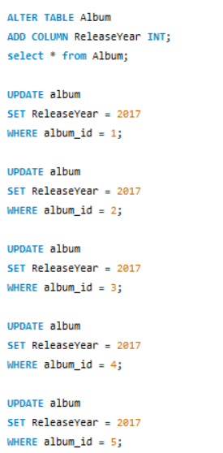 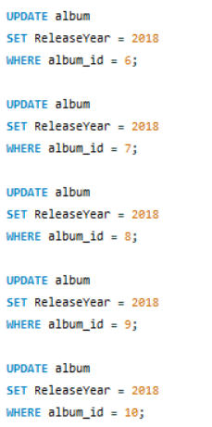

**Updated Table Output –**

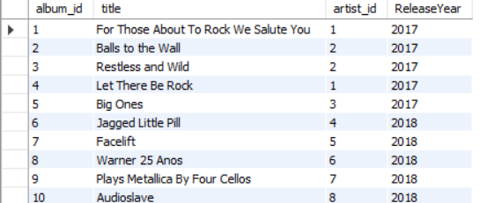

1. **Chinook is interested in understanding the purchasing behaviour of customers based on their geographical location. They want to know the average total amount spent by customers from each country, along with the number of customers and the average number of tracks purchased per customer. Write an SQL query to provide this information.**

**Ans –**

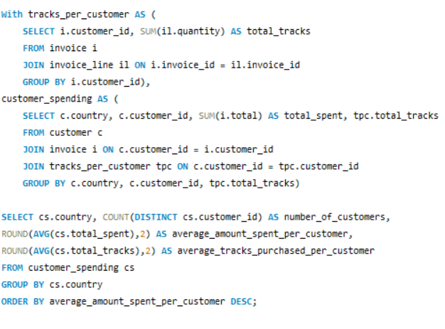

**Table Output –**

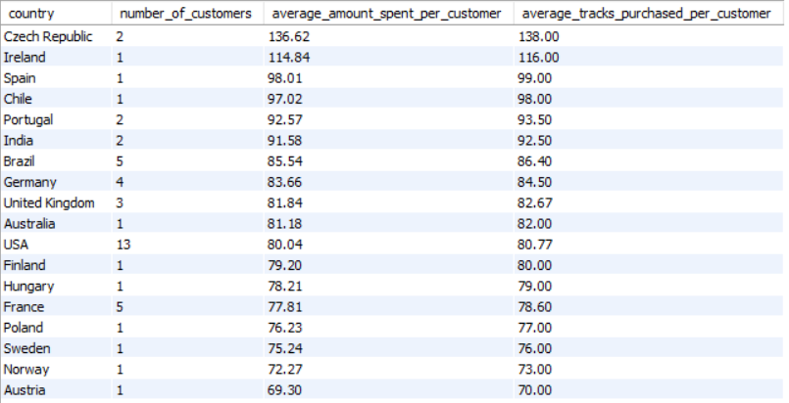

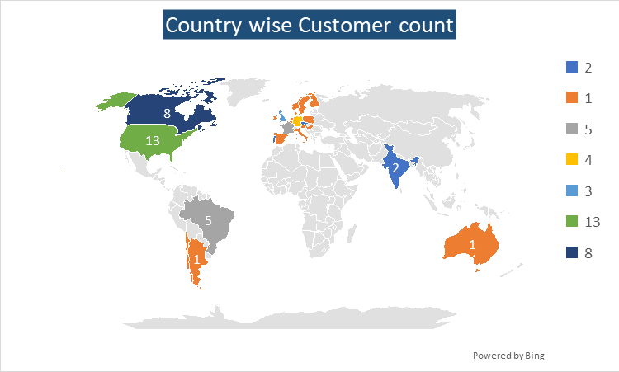

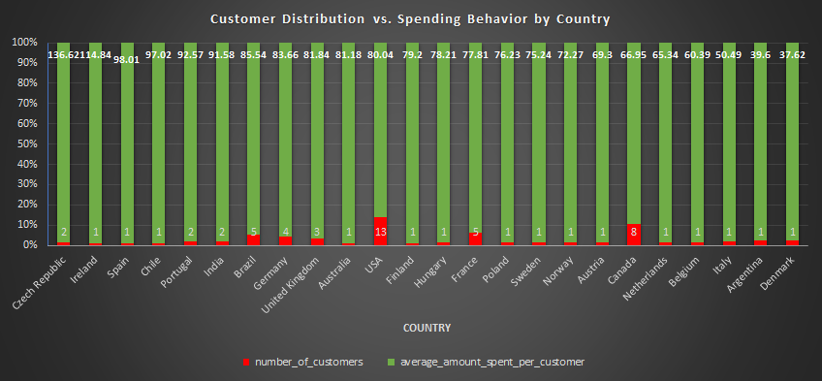

**INSIGHTS:**

* + The **Czech Republic** has the **highest** average amount spent per customer at **$136.62**, indicating high customer value in this region.
  + The **USA** has the **largest customer base with 13** customers but a lower average spend of **$80.04**, suggesting a broad but less intense engagement.
  + Customers from India, Portugal, and Brazil show moderate average spending, ranging from **$85.54 to $92.57**, with **varied customer bases**.
  + Countries like **Argentina and Denmark** have the **lowest average spend per customer**, **around $40**, reflecting limited purchasing activity.
  + Countries with only **one customer, like Ireland and Spain**, have relatively **high average spends**, highlighting significant individual contributions.

**=================== END OF SUBJECTIVE QUESTIONS ===================**